**KIET Group of Institutions, Ghaziabad**

***Computer Science & Informatiom Technology***



**PROJECT BASED LEARNING**

**ON**

**STUDENT RECORD SYSTEM**

**SUBJECT: Data Structure Using C lab**

**(KCS-553)**

**Submitted By:**

**Anay Dwivedi(2100290110027)**

**Aman Dwivedi(2100290110017)**

**B-Tech/CSIT/3A**

**ACKNOWLEDGEMENT**

I’ve got this golden opportunity to express my kind gratitude and sincere thanks to my subject faculty **“Mr. Vinay Kumar”**, Computer Science and Information Technology Department, **KIET GROUP OF INSTITUTIONS** for their kind support and necessary counselling in the preparation of this project report. I’m also indebted to each and every person responsible for the making up of this project directly or indirectly.

I must also acknowledge or deep debt of gratitude each one of my colleague who led this project come out in the way it is. It’s my hard work and untiring sincere efforts and mutual cooperation to bring out the project work. Last but not the least, I would like to thank my parents for their sound counselling and cheerful support. They have always inspired us and kept our spirit up.

**Aim**

Create a System to store , display,and delete the data of students in C Language.

**Objective**

we use Link-list and Array concept of data structure to achieve the aim and implement it in our working project.

In Student Registration System any institution can register any new student details.

It also comprises of displaying all registered students following details

* Students Name
* Parents detail
* D.O.B
* Address

**Abstract**

With Student Registration System (SRS) is a solution tool that is designed to track, maintain and manage all the data generated by a School, including the grades of a student, their attendance, their interpersonal activities records, etc.

**Basic principle**

It is used to store the data of student in online format so to reduce the time and cost of college and university.

We have made several functions in our system to perform different tasks

* **add_student()**

//this function is used to add students detail i.e. Studentname,parents name,D.O.B.,address etc

* **displayallstudents()**

// it is used to display all the detail regarding students which we have given in add_student() function.

* **main()**

//it contain all the information regarding student registration system.

**Methodology**

we are using the following technology for this :-

* **Singly linked list** : A singly linked list is a type of linked list that is unidirectional, that is, it can be traversed in only one direction from head to the last node (tail). Each element in a linked list is called a node. A single node contains data and a pointer to the next node which helps in maintaining the structure of the list.
* **Array :**Array in C can be defined as a method of clubbing multiple entities of similar type into a larger group. These entities or elements can be of int, float, char, or double data type or can be of user-defined data types too like structures.
* **Structure:** Structures (also called structs) are **a way to group several related variables into one place**. Each variable in the structure is known as a member of the structure. Unlike an array, a structure can contain many different data types (int, float, char, etc.).

**Architecture**

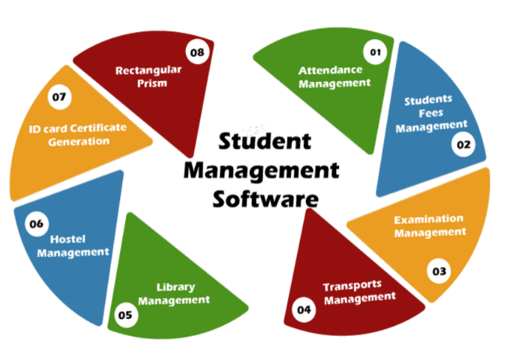

**CODING IMPLEMENTATION**

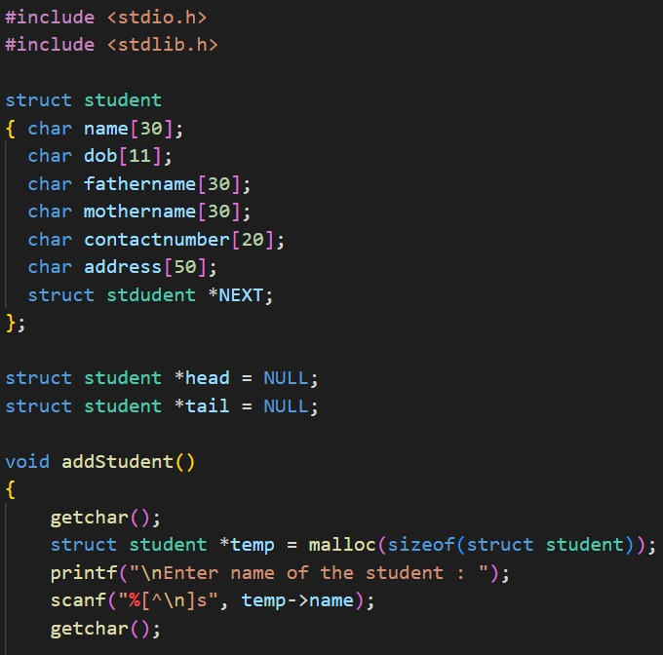

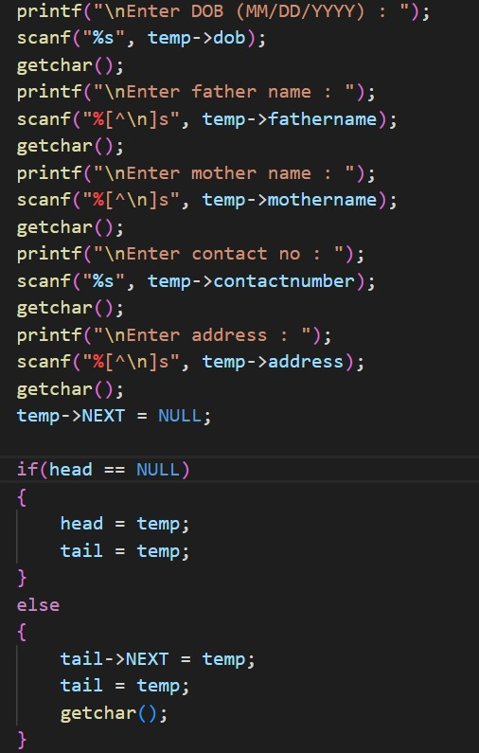

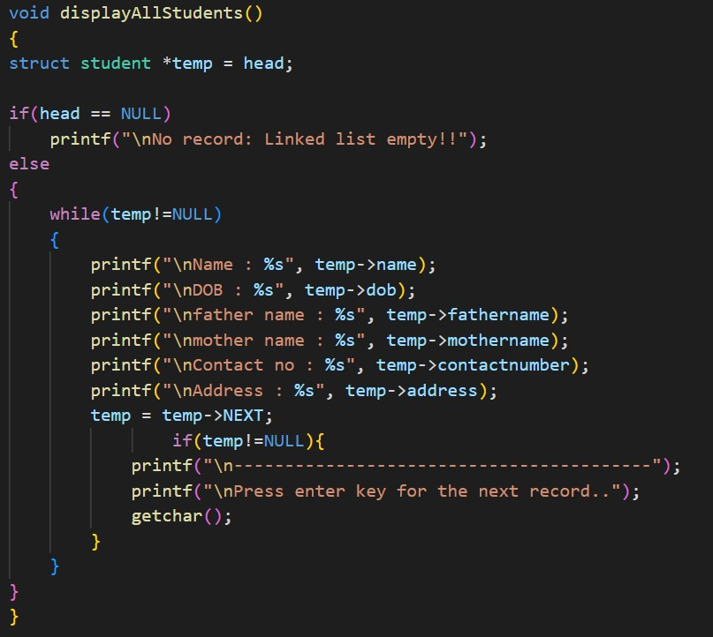

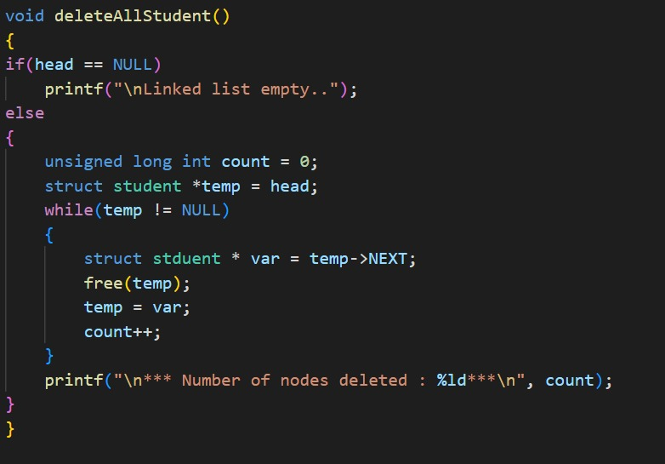

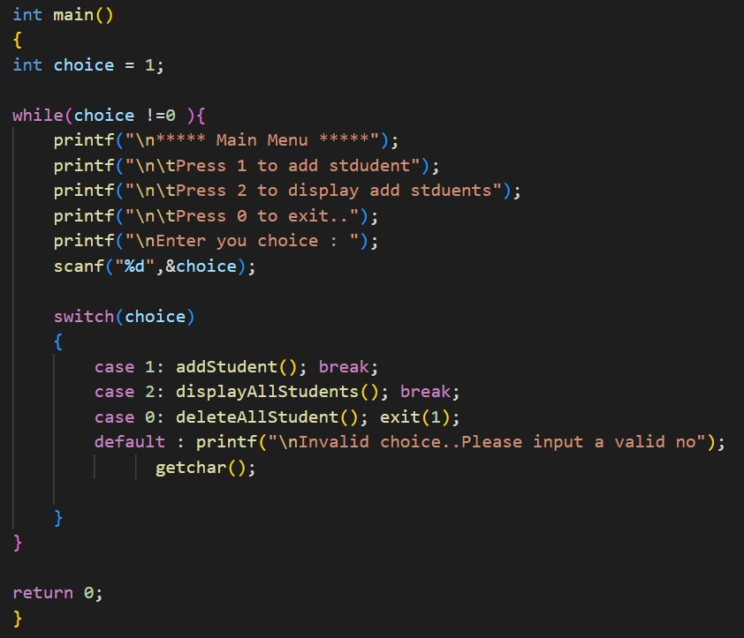

**OUTPUT**

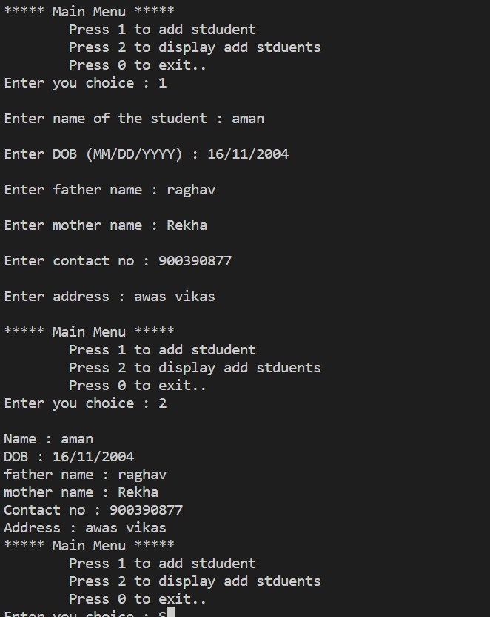

**References**

1. [**https://www.geeksforgeeks.org/data-structures/linked-list/singly-linked-list/**](https://www.geeksforgeeks.org/data-structures/linked-list/singly-linked-list/)
2. [**https://www.w3schools.com/c/c_structs.php**](https://www.w3schools.com/c/c_structs.php)
3. [**https://www.youtube.com/watch?v=E9HHKiwvlH8**](https://www.youtube.com/watch?v=E9HHKiwvlH8)